Enhancment for Regdoc

we need to add the tpp policy as a state so that user can acess as the state

1.) user wants that tpp policy state forms should come as single multi state every charactersitics come under one state
2.) for this policy if we there will be only gl and irpm lob's and for that lob's the state forms should be different
3.) same characterstics for all states

how to do
1.) we need to update the tables frst one is state table
2.) next tmp table
3.) co lokup table
4.) next eligible matrix table

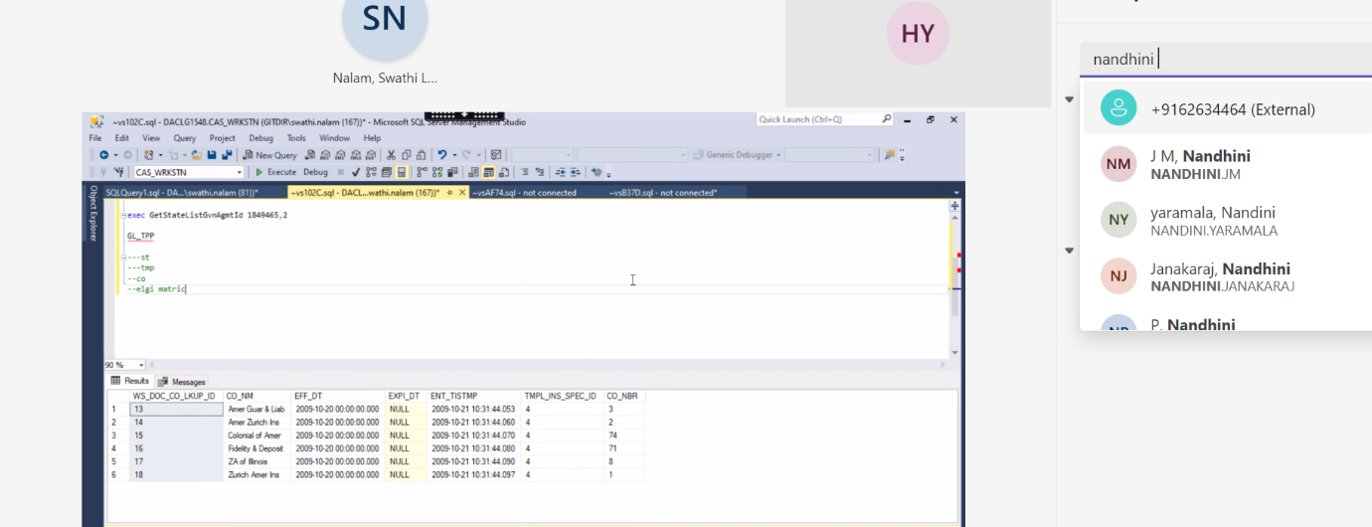

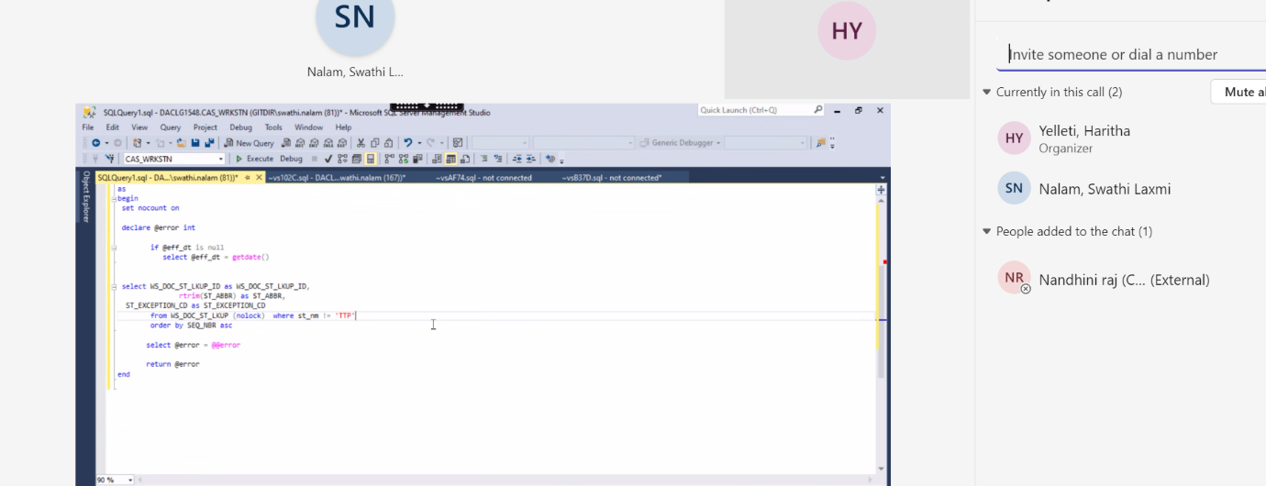

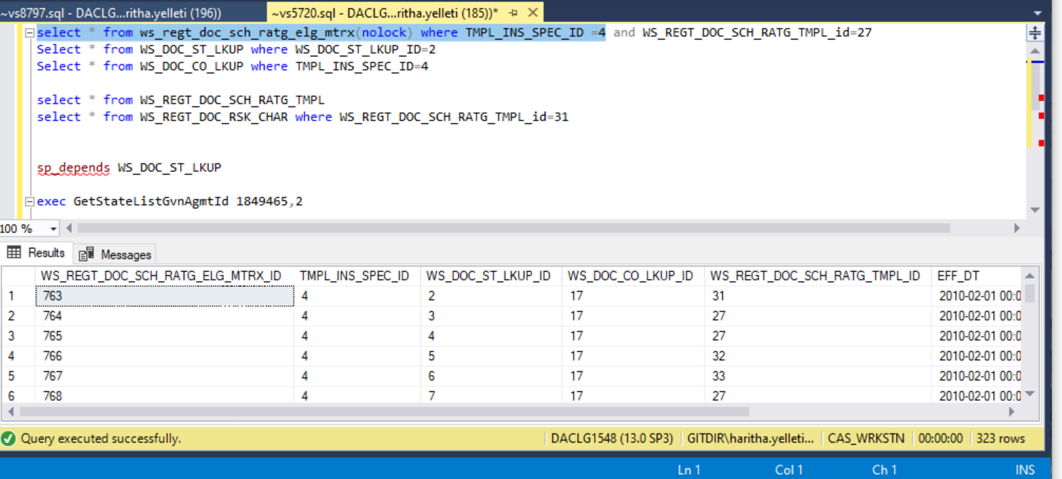

select * from ws_regt_doc_sch_ratg_elg_mtrx(nolock) where TMPL_INS_SPEC_ID =4 and WS_REGT_DOC_SCH_RATG_TMPL_id=27
select * from WS_REGT_DOC_SCH_RATG_TMPL where WS_REGT_DOC_SCH_RATG_TMPL_ID=27

-- here TMPL_INS_ID=4 consists of GL schedule rating and WS_REGT_DOC_SCH_RATG_TMPL conists of lob_state list where 27 is GL_MULTIstate

Select * from WS_DOC_ST_LKUP where WS_DOC_ST_LKUP_ID in (3,4,7,9,10,13,14,15,16,17,18,19,20,21,23,24,25,26,27,29,30,31)
---here WS_DOC_st_LUP consists of states names with st_abbrv
Select * from WS_DOC_CO_LKUP where TMPL_INS_SPEC_ID=4
-- here ws_doc_co_lkup consists of projects where gl has 6 projects
select * from WS_REGT_DOC_SCH_RATG_TMPL
select * from WS_REGT_DOC_RSK_CHAR where WS_REGT_DOC_SCH_RATG_TMPL_id=31
--here WS_REGT_DOC_RSK_CHAR table conists of risk characertics for each state
sp_depends WS_DOC_ST_LKUP
exec GetStateListGvnAgmtId 1849465,2
GL_TPP
---st
---tmp
--co
--elgi matric
has context menu

